Forensic Engineering - Vehicular accident reconstruction
Revised from:
http://resources.edb.gov.hk/gifted/ForensicSci/Files/L7/4_Lesson7_worksheets.doc

Pre-lesson Reading:

Introduction
Vehicular accident reconstruction is the scientific process of investigating, analysing, and drawing conclusions about the causes and events of a vehicular collision. Forensic investigators are employed to conduct in-depth collision analysis to identify the causes of collisions, including the role of the driver, vehicle, road condition and the environment.
The laws of physics such as the conservation of linear momentum, work-energy and kinematics are the basis for the analysis and may be employed to handle the different variables. Accident reconstructions are done in court cases involving death and personal injury. Results from accident reconstructions are also useful in developing recommendations for making roads and highways safer, as well as improving safety aspects of motor vehicle designs.
Investigation. The purpose of Accident scene inspection is to recover data for further investigation of all of the vehicles involved in the collision. The investigations include collection of evidence such as scene photographs, videos of the collision, measurements of the scene and eyewitnesses’ confessions. Additional information such as steering angles, braking distance (with / without braking), use of signal lights/ hazard lights, car speed and acceleration will also be obtained. Witnesses are interviewed to get more evidence for accident reconstruction. Physical evidence such as skid marks of tires is also examined. The length of a skid mark can often allow calculation of the original speed of a vehicle. Vehicle speeds are frequently under-estimated by a driver, so an independent estimate of speed is often essential in accident investigations. Inspection of the road surfaces is also vital - icy road, oil spill from a vehicle or obstacles such as road debris may affect the friction of the road surfaces.
Analysis. The process of vehicular accident reconstruction includes data processing and analysis as well as evaluation of different possible hypotheses according to test results / modeling result from software simulations. Accident reconstruction software is regularly used by law enforcement personnel and consultants to analyse a collision and to demonstrate what may have happened in an accident.
A short video on car crashes: http://www.youtube.com/watch?v=u96_CgE86ys
Accident Scene Investigation

A serious traffic accident happened on March 19, 2010 on the highway at North Lantau Island, in Hong Kong. A black Rolls Royce stopped on the highway because of a flat tire. The driver got off the car and walked to the rear of the car to for the spare tire in the trunk. Unfortunately, a white car driving on the same lane crashed into the Rolls Royce. Both cars were damaged seriously and the driver of the Rolls Royce was killed.
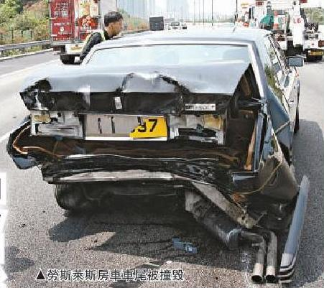 Figure 1
7
5
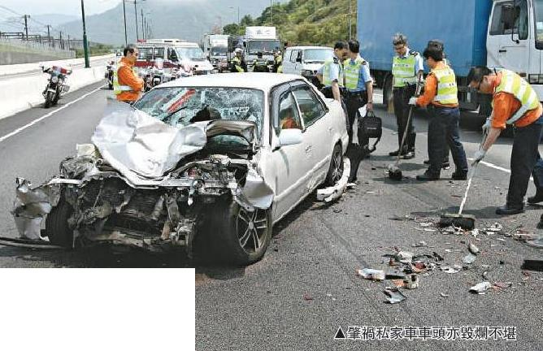
Source: Tai Kung Pao
(3-20-2010)
Figure 2
1
2
3 , 4
6

Suppose you were a forensic investigator and arrived at the location after the accident. According to the above photos, what would you do in order to identify the causes of the accident? Use the photos (#1-7) on page #2 as a guide.
(This is an open-ended question and there are a lot of possible answers. Write as much as you can with your common sense and justify your answers with reasons.)

Things you would do | WHY ?
1
2
3
4
5
6
7
In the space below, come up with a “top ten” list of reasons why car accidents occur.

Reaction time of the driver

Reaction time is the lapse of time between stimulation and the beginning of response. Suppose you were driving on the highway and listening to the music you like most, suddenly, you saw the brake lights of the car in front of you, you tried to hit the brake to slow down your car…But, there is a small time delay before you can really do that - your reaction time. During that period of time, your car is still moving at the same HIGH speed! Calculate how many feet your car will travel in the following times assuming you’re traveling the speed limit @ (65 mi/hr)

Typical reaction time of driver under different conditions:

Conditions | Reaction time | Feet Traveled
Normal | ~ 1 sec
Having telephone conservation /  Listening to loud music | ~ 1.5 – 2 sec
Texting | ~ 3 – 4 sec
Drunk or under medication | ~ 2 – 5 sec

The total stopping distance is composed of 2 parts :

- Thinking distance:
the distance travelled by the car in your reaction time.

- Braking distance:
the distance skidded by the car after the brakes are applied.

Total stopping distance = Thinking distance + Braking distance

From this point forward, we will be doing all of our calculations in metric.
Answer the following questions: You must draw a FBD for #2 and #3, and show all your work on a separate sheet.

- If you drive at the speed limit 65 mi/hr, how far do you travel per second?
- If you have a reaction time of 1.25 seconds, and μ_{k} = 0.8 between the dry road and tires, how far will your car travel before coming to a stop? How far will your car travel if the road is icy and μ_{k} = 0.16?
- Using a mass of 70-kg, what average force would your body ‘feel’ during the dry road skid? The icy road skid?

The following ‘Reaction time” animation demonstrates how the reaction time affects the total stopping distance of the car:
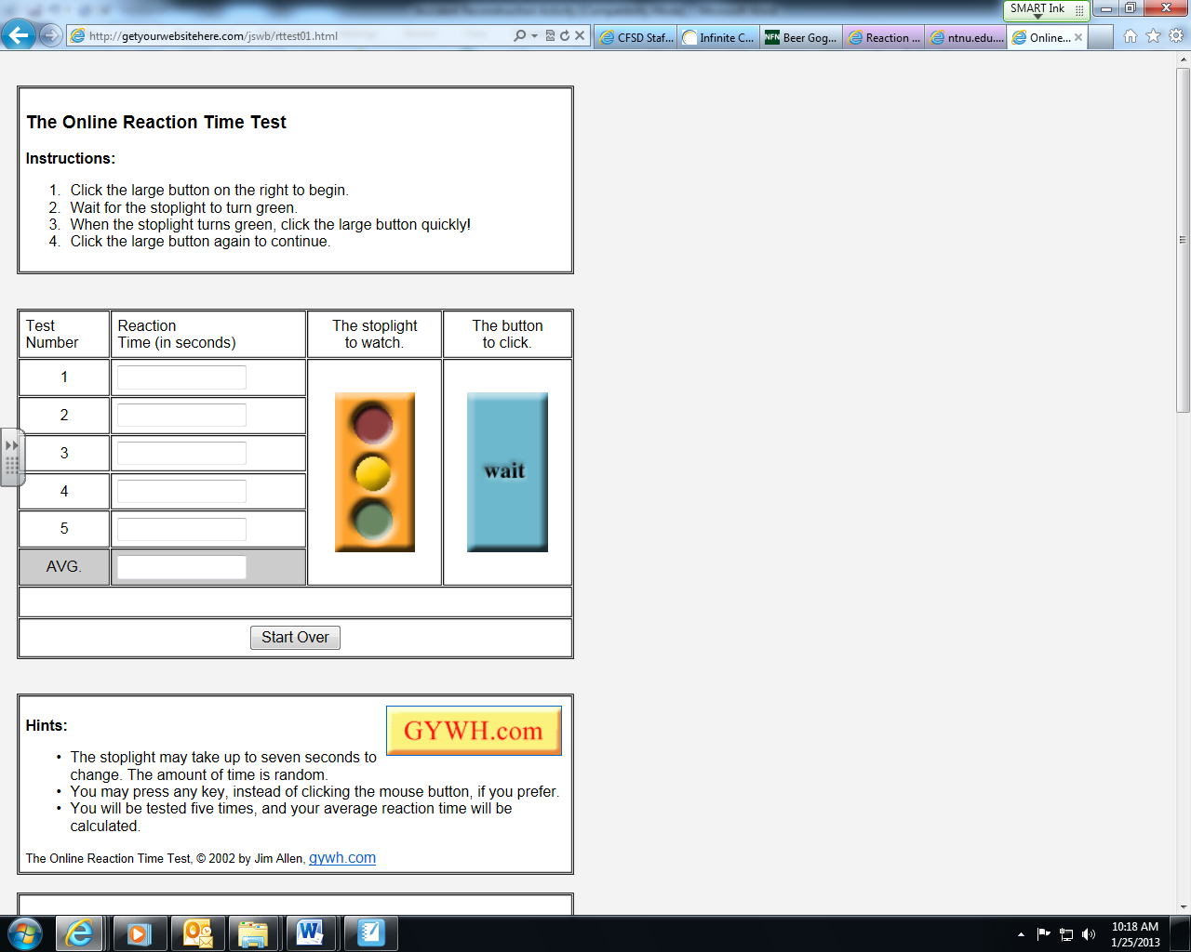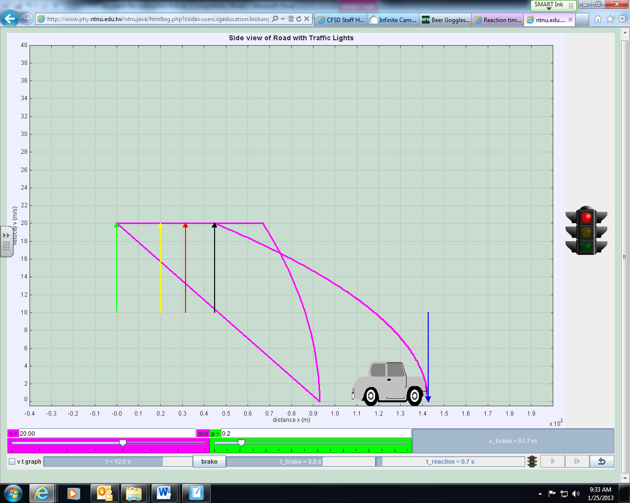
Reference websites for the reaction time:
- http://getyourwebsitehere.com/jswb/rttest01.html (Reaction time)
- http://www.phy.ntnu.edu.tw/ntnujava/htmltag.php?code=users.sgeducation.lookang.reactionTimewee_pkg.reactionTimeweeApplet.class&name=reactionTimewee&muid=14019 (stopping distances)

Test your normal reaction time using the first simulation above. Record your average for the five trials in the table below. Simulated conditions:
- Normal (baseline) reaction time;
- Listen to loud music when you take the test on reaction time (use headphones);
- Send/Receive a phone call when you take the test on reaction time;
- Send/Receive a text message when you take the test on reaction time;
- Spin in a circle ten times and then take the test on reaction time immediately (only do this once…I don’t want anyone to puke!).
Redo the above 5 using simulation #2 (Set v = 30 m/s, and μ = 0.8), to find distance traveled. Record these in your table below. (Be careful, x10² m on the X-axis)
 | Normal | Music | Phone | Text | Spun
Time (s)
Distance (m)

What can you imply from the results of your tests?

Note: The reaction time tested in this animation may be much faster than the real situation. Real drivers use their feet to hit the brake which may need a longer time for the signal communication with the brain. Besides, real driver are easily distracted by different conditions on the road while the students are highly concentrated on taking this test.

The Effects of Drinking & Driving:
The statistics for teenage drinking and driving are saddening. This activity is fun, but remember…this is not a game: Here are some facts worth remembering.
Almost every 90 seconds, a person is injured in a drunk driving crash.
In 2011, 9,878 people died in drunk driving crashes - one every 53 minutes! (Many were teens)
One in three people will be involved in an alcohol-related crash in their lifetime.
Drunk driving costs each adult in this country almost $500 per year. ($155,000,000,000/year)
One in five teens binge drink. (In WI, this statistic is closer 1 in 4)
Teen alcohol use kills about 6000 people each year, more than all illegal drugs combined!
Car crashes are the leading cause of death for teens!
Directions: Do the following activities without the goggles on, and record your score below. Place the “Beer” Goggles on, have a partner assist you at all times!

Activities: For each successfully placed or caught tennis ball, score 1 point.
- Pick up one tennis ball at a time and place it in the box 10 feet away. (5 balls)
- Have your partner toss you 1 tennis ball at a time. (+1 pt/catch) (5 balls)
- Kick a tennis ball. (+1 pt for each kick made) (5 times)
- Walk a ‘heel-to-toe’ 15 foot line. (+1 pt, each step on the line) (max = 15 pts)
- High-Five your partner. (5 times)
- Stand on one leg for 30 seconds (+1/2 pt for every 2 seconds balanced) (mas = 15 pts)

Score Normal_____________________/50

Record BAC of the goggles____________score with Goggles____________________/50

Why is drinking and driving a horrible idea?

Visual Limitations and Driver Perceptions:
As a class, watch the following three clips…
http://www.youtube.com/watch?v=4GYwPPRDrHI (Delusions of Brain 1 of 4 from NatGeo’s Brain Games)
http://www.youtube.com/watch?v=YJbKieEC49M (Eye Tracking)
http://www.youtube.com/watch?v=vJG698U2Mvo (Selective Attention)
Many time drivers become so focused on the act of driving, they lose focus of the big picture. After watching the video clips above, explain why the following situations would be dangerous.
- Driving at night (or in the early morning, or evening), when shadows are prevalent.

- Driving while focused in on one object; say the taillights of the car directly in front of you.

- Driving with a car full of friends.

Features of skid marks
In a car accident, a skid mark is the mark a tire makes when a vehicle wheel stops rolling and slides on the surface of the road, much like that of an eraser leaving pieces of rubber on a paper, and is an important aspect of trace evidence analysis in forensic science and forensic engineering.
Different inflation of tires will lead to different appearances of the skid marks. Try to finish the matching game below and give reasons for your choices.
Tires’ conditions | Normal inflation  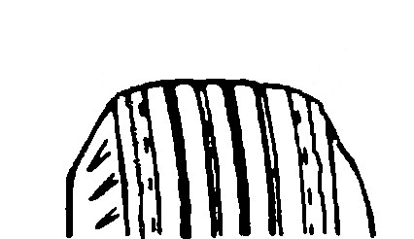  A | Under-inflation  Rapid wear at edges  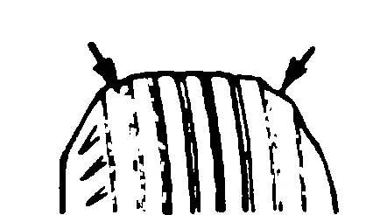  B | Over-inflation  Rapid wear at centre  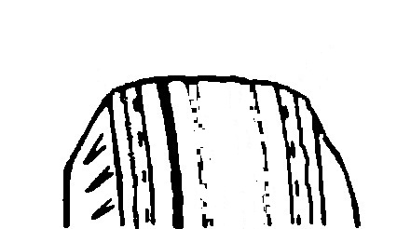  C
Contacts with road  (diagrams showing vertical sections of tires contacting with road surface) | ◎ ◎ ◎  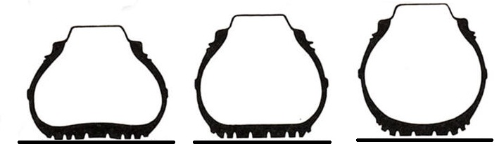  1 2 3
Appearances of the  skid marks | I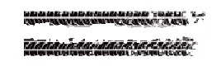 | II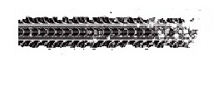 | III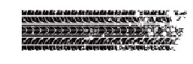

Note: Tire wear may not lead to total disappearance of the striation. The striation may become shallower when compared to that of the normal area.
Actually, there are numerous patterns of skid marks due to the different situation of the vehicles (e.g. accelerating, turning round, drifting, moving backward and sideslipping). The appearance of each skid mark pattern is special but an experienced forensic engineer can obtain much valuable information by examining the marks left by the tire.
References on skid marks:
http://en.wikipedia.org/wiki/Skid_mark
http://www.harristechnical.com/articles/errors.pdf
http://collisionanalysis.co.uk/introduction.htm
http://www.easts.info/on-line/journal_06/3441.pdf

START and STOP (ACCELERATIONS)
The manufacturer of BMW quotes that the model BMW 530i can accelerate from rest to a speed of 100 km/h (27.8 m/s) in 6.5 seconds, while a Collora E140 can have the same acceleration in 9.8 seconds. It is obvious that BMW has a higher horsepower. We can calculate the acceleration of both cars to make a clearer comparison.

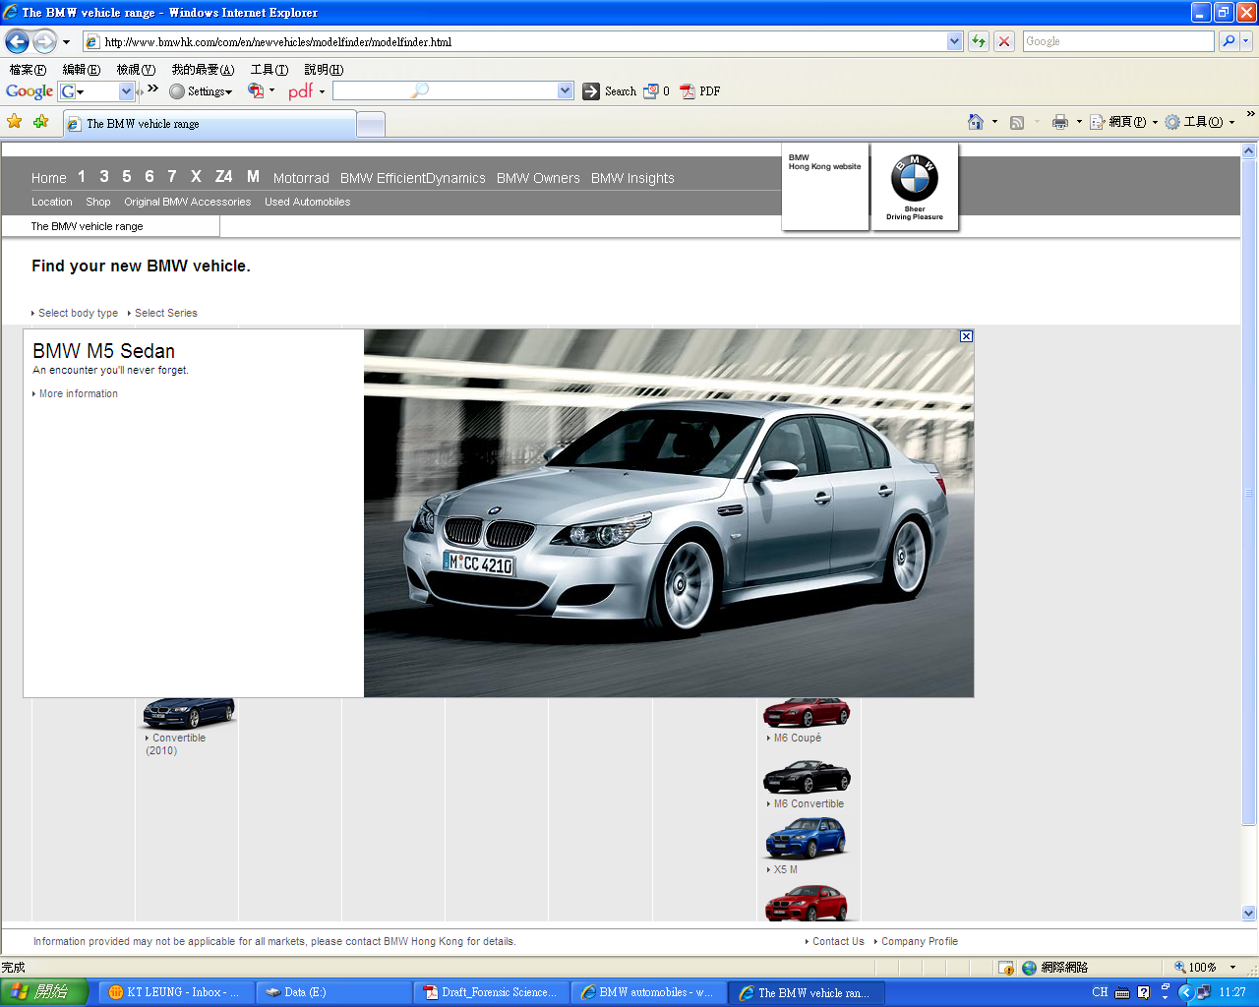
Source: http://www.bmwhk.com/com/en/newvehicles/modelfinder/modelfinder.html
(BMW Concessionaires (HK) Ltd.)
BMW 530i
Acceleration = the rate of change of the speed
a = (ν_{f} - ν_{i}) / t
(ν_{f} = final speed of the car)
(ν_{i} = initial speed of the car) ( 1 km/h = 0.278 m/s)
In the above example, ν_{i} = 0 since the cars start from rest. The acceleration of BMW and Collora are 4.28 m/s² and 2.84 m/s² respectively.
Besides, we can also calculate the distance travelled by the car during the process of acceleration by the equation of motion:
ν_{f}² = ν_{i}² + 2ad
a = acceleration in m/s
d = distance traveled in m
Apply the equation to complete the following table:
Car type | BMW 530i | Collora E140
Acceleration | 4.28 m/s² | 2.84 m/s²
Distance traveled in (m) (From rest to 100 km/h)
The braking of a vehicle
When a car is moving on a road without applying the brake, the tires are rolling on the ground and no significant mark will be left on the road. Once the brake is applied, the wheels are locked without rolling and the tires will slip on the road causing skid marks on the road surface. The length of the skid marks begins when the brake is applied and ends when the car stops.
Actually, it is the friction between the tires and the road surface that causes the car to decelerate and stop. The following experiment allows you to investigate the relationship between the friction of an object and its weight.
Experiment
Place a tire on a surfaced. Then attach a force sensor (Vernier-computer) to the tire and pull the tire horizontally (Figure 1) at a constant speed. Observe and record the reading on the computer when the tire slides on the surface. This is the force due to friction between the tire and the surface. Redo the experiment 5 more times by adding mass to your tire on each new trial. Record your surface here________________.

Figure 1
Figure 2
PULL

Measure the total weight of the tire and the weights. (Figure 2)
Complete your data table below:
 | Trial 1 | Trial 2 | Trial 3 | Trial 4 | Trial 5 | Trial 6
Friction F (N)
Total weight W (N)
Ratio F / W
In Logger Pro, create a graph of Friction vs. Weight. Fit a linear regression line to your data and explain what the slope of this line represents below:

You will find that the ratio of F / W is the same so that we can express the relation as
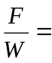 constant OR
( F = constant x W )
In forensic science, we define the constant as μ, the drag factor for the road surface. We can conclude that μ is a factor which depends on the nature of the tire and the road surface but independent to the weight of the vehicles. (In physics, μ is called the coefficient of friction) In many car accidents, the forensic investigator will make an on-site test about the tire/road condition. It is known as the “drag test”. 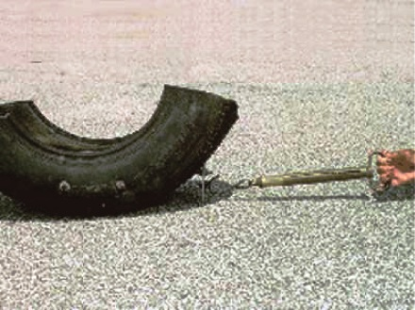
http://www.musclemustangfastfords.com/tech/mmfp_0610_bolt_on_performance_parts/index.html
As we have proved in our experiment, the drag factor does NOT depend on the weight of the vehicle! Only a part of the tire is needed for measuring the ratio F /W.

F
W
For normal tire’s condition, the drag factor depends on the nature of the road surface. Here are some examples of μ (drag factors):
Cement : 0.55 – 1.22
Asphalt : 0.50 - 0.90
Gravel : 0.40 – 0.80
Snow : 0.10 – 0.50

Police commonly uses 0.7 for the drag factor under normal condition.
The higher the speed of the car before braking, the longer the distance needed for the car to stop. By measuring the length of skid marks, it is possible to estimate the vehicle speed just before sliding by the following formula:
ν_{i} = √(19.6μd)
Where ν_{i}: speed just before sliding (measured in m/s)
μ : drag factor (unitless)
d: length of the skid mark (measured in m)
Question:
Assume the braking efficiency of the car is 100 %, prove using your knowledge of kinematics that the initial velocity is indeed equal to:
ν_{i} = √(19.6μd)

Problem:
A car skids to a stop on a road in Altoona, leaving four skid marks with an average length of 45 m. Skid tests reveal a drag factor of 0.70. Estimate the speed of the car just before sliding in miles/hour. Show all your work below.

Answer: __________________________________

Notes:
- It is important to understand that this is the MINIMUM speed of the vehicle at the beginning of the skid. Remember, we assumed 100% efficient braking.
- It is not possible to find all of the skid marks – skid marks start out as light shadow marks but would become progressively darker (→ more difficult to see).
- This formula assumes that the vehicle comes to a stop at the end of the skid without hitting anything such as another car or a tree.
- If there is a speed value at the end of the visible skid, as when the car strikes something, the residual speed value must be combined with the calculated minimum skid speed.

Case study-Midnight Crash

Your group is the investigation team providing expert testimony at an automobile
accident case in the court. The case involves a lady driver (Carol) driving a red car which knocked down a young male pedestrian (Henry) around midnight at a road junction in Chippewa. The driver was not injured and passed the alcohol test. However, the pedestrian was hurt badly. An eyewitness (Sam) reported to the police that he saw part of the accident. The following sketch was drawn by your colleague (a police officer) 1 hour after the accident:

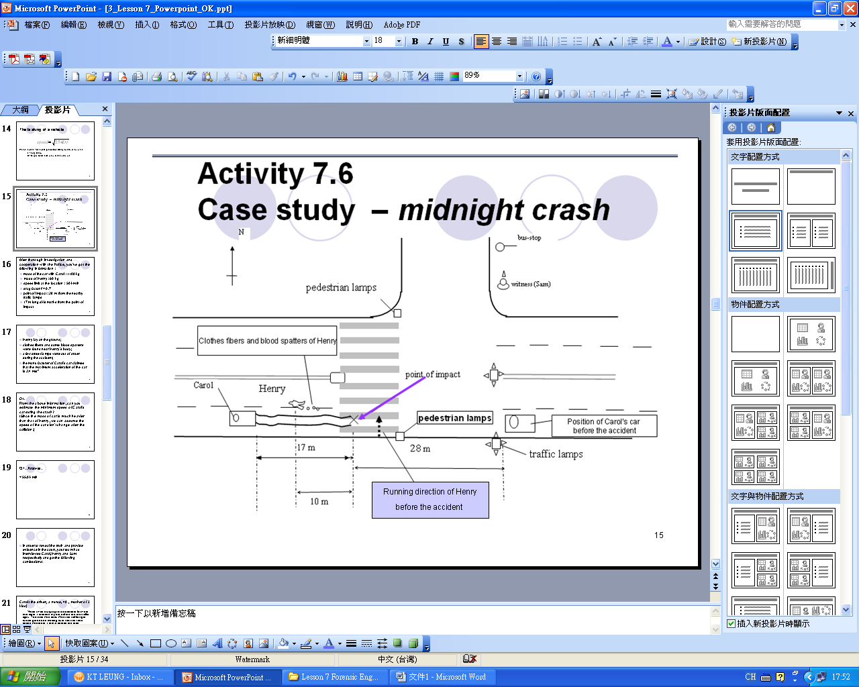

(The positions of Carol , Henry, and Sam in the above sketch are predicted positions during the accident)
WI Law: http://www.dot.wisconsin.gov/safety/motorist/pedestrians/rules.htm
After thorough investigation you get the following information from the site:
- mass of the car and Carol: 1100 kg
- mass of Henry: 60 kg
- speed limit at the location: 30 mi/hr
- drag factor f = 0.7
- point of impact: 28 m from the nearby traffic lamps
- 17 m long skid marks from the point of impact
- Henry’s estimated impact location and location on the ground
- clothes fibers and some blood spatters were found near Henry’s body
- a few street lamps were out of order during the accident
- the manufacturer of Carol’s car claimed that the maximum acceleration of the car is 2.4 m/s²

Q1. From the above information, estimate the minimum speed of Carol’s car during the crash? (Since the mass of car is much heavier than that of Henry, we can assume the speed of the car didn’t change after the collision)

Answers:

_____________________________________________________________________

In order to reveal the truth and provide evidence in the court, your team had interviewed Carol, Henry and Sam respectively and got the following confessions.

Carol (the driver, a nurse, 40, mother of 3 kids)
When I was hurrying to the hospital for work that night, I stopped my car before the red traffic light. The road was dark. After the traffic light turned green and making sure that the road ahead was clear, I drove across the road junction. Suddenly, I saw a person wearing dark clothes appearing in front of me. I swear that I couldn’t see him until the last moment. I pressed my horn sharply but he didn’t seem to have any response. Everything was too late and my car knocked him down. I applied the brake immediately to stop my car. I was so scared that I stayed in my car until the police came.
Henry (the injured person, a salesman, 26, single)
After drinking with my friends, I left the bar around midnight. I intended to catch the last bus home. The pedestrian lamp was green and flashing when I was running across the road. Suddenly, without sounding its horn a car at high speed came to me from my right hand side and knocked me unconscious.
Sam (witness, a financial planner, 33, married)
That was a quiet night. When I was walking towards the bus-stop after meeting with a client, I heard loud sound of a horn from behind. I turned to my left and saw a car knocking down a person. I remember that the pedestrian lamp near the crash scene was still red at that moment. I ran quickly across the road to see how I could help. I saw a man wearing black clothes lying on the road with some bloodstains around him. A car stopped about 10 m away from the injured person. The driver, who was a lady, got out of her car. She was very scared! I called 911 with my cell phone to get help.

Q2. Comparing the confessions of Carol, Henry and Sam list out some points that you think are contradictory.

Answers:

Q3. Comment on the confessions and discuss whether they are: trustworthy “(✓)” or doubtful “(?)”.

Carol:
( ) The road was dark.
( ) I had pressed the horn.
( ) I had braked the car after knocking down Henry.
( ) I stayed in the car until the police came

Henry:
( ) I was running when I was knocked down by the car.
( ) The pedestrian lamp was green / flashing.
( ) The car did not sound its horn.

Sam:
( ) I heard the horn before the collision.
( ) The car stopped about 10 m from the body
( ) The pedestrian lamp was red during the collision.
( ) The driver got out of her car.

Animation of vehicle’s accident

Today, computer generated animations can be used to pool together all the relevant evidences from forensic investigations and the confessions of the people involved in the accident and give a visual demonstration of related events logically and clearly. Very often such animations are used in attending meetings or providing courtroom presentation.

Here are some examples of Accident Animations: http://www.youtube.com/watch?v=Dt53sjfCEJw
The animation is based on the footage of a real accident. The animation includes the Jogger View, Second Pedestrian View and Car Across Intersection View. Luckily, the person run over in the animation did survive in the accident!
Reference for the animation: http://www.mapscenes.com/software/capture/samples/index.htm
Follow-up activities
ON or OFF ? Lamp Examination after a Collision

In many traffic accident cases, witnesses or drivers will claim that one of the
accident vehicles did not have its lights on during a night time accident or the taillights and hazard lamps are off when the vehicle stops suddenly, which can account for the responsibility of the accident.

Vehicle lamps can be examined to determine if they were on or off at the moment of impact. The majority of lamps used in vehicle tail lights are incandescent. (However, more are using LED.) They are the same as household light bulbs. The filaments, the tightly coiled wires running between two upright support posts, are made from tungsten, a very hard metal.

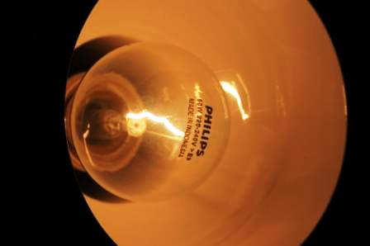
filament

When electric current passes through a filament coil, the temperature of the wire is raised to 2000ºC and white light is produced (incandescence).

At normal environmental temperatures, tungsten does not react with oxygen in the air. However, tungsten can be oxidized rapidly at incandescent temperatures in the presence of air. In standard lamps, the air inside was removed and replaced with nitrogen, an inert gas that will not oxidize with tungsten. When the filament reaches incandescence, the nitrogen gas prevents oxidation. Light will be produced continuously.

Figure 1 and 2 show the tungsten filaments of two lamps. One of them was broken due to collision when the lamp was on. Which one is it? Explain your answers.
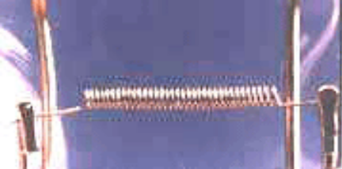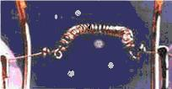
Figure 1 Figure 2

Answers:

Yaw marks and rotation of vehicles

There are various types of tire marks; the two most common ones are straight-line skid marks (discussed in previous section) and yaw marks. The presence of straight-line skid marks indicate that a tire is not rotating, either due to braking or as a result of damage sustained during a collision.
Yaw marks often occur when a driver makes a hurried steering (a) to avoid an object on the road, or (b) to remain on the pavement while entering a curve too fast or (c) while overcorrecting a previous situation. A yaw mark is that physical mark on the roadway caused by the rotating tires of a vehicle slipping in a direction parallel to the axle of the wheel during a maximum rate of change of direction.


Figure 3

Source: http://www.kineticorp.com/publications/2009-01-0092-yaw-striations-steering-braking.pdf
Yaw mark indicates rotation of a vehicle, as would occur when a vehicle “spins out”. Yaw marks are generally curved, and the striations are at an angle to the marks.

Driver gives a sudden steering to the left
Due to inertia, the car keeps sliding forward
Striation makes an angle with the sliding direction of the car
Yaw mark formed behind the wheel

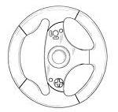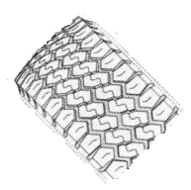

References :
- Rivers, R.W. (2006). Evidence in Traffic Crash Investigation and Reconstruction: Identification, Interpretation and Analysis of Evidence, and the Traffic Crash Investigation and Reconstruction Process. Illinois: Charles C Thomas Publishers Ltd.
- Genge, N.E. (2002). The Forensic Casebook: The Science of Crime Scene Investigation. NY: Ballantine Books.
- Nickell, J. & Fisher, J.F. (1999). Crime Science: Methods of Forensic Detection. Kentucky: The University of Press of Kentucky.
- Wong, S.S. & Pang W.C. (2009). Physics at Work: Force and Motion (Teacher’s Edition). Hong Kong: Oxford University Press (China) Ltd.
- http://www.metacafe.com/watch/2382492/car_crash_compilation/
- http://en.wikipedia.org/wiki/Skid_mark
- http://www.harristechnical.com/articles/errors.pdf
- http://www.donan.com/Services/Vehicle-Accident-Reconstruction/Passenger-Vehicles.aspx
- http://collisionanalysis.co.uk/introduction.htm
- http://www.easts.info/on-line/journal_06/3441.pdf
- http://www.shep.net/resources/curricular/physics/java/javaReaction/index.html
- http://www.humanbenchmark.com/tests/reactiontime/index.php
- http://www.donan.com/Services/Vehicle-Accident-Reconstruction/Passenger-Vehicles.aspx
- http://www.accidentreconstruction.com/news/Default.aspx

