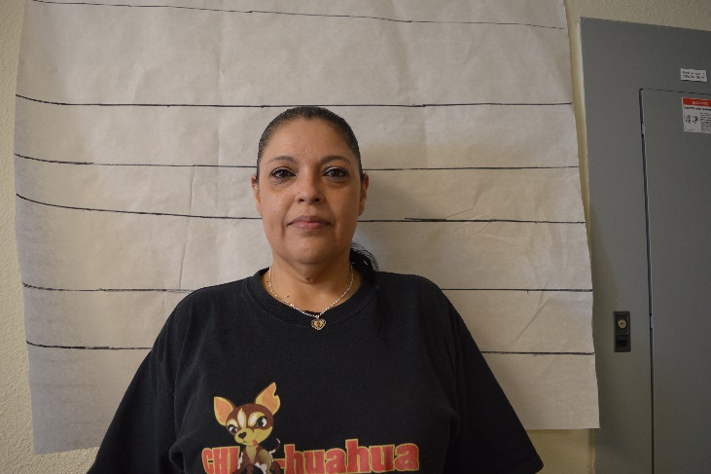 |  | Relationship to the Professor:  - Neighbors;  - Runs into the Professor when he is working in the lab in the afternoon/evening;  - Has lab access;  - Have been neighbors for years  - Friends by all accounts  Alibi: On Saturday, my usual routine is to wake up early and get to a Zumba class at the gym. So I did that and then I went to the grocery and picked up a few things before heading home for a while. At about 4pm I headed over to the school to check on an alarm that was going off. When I got there, Mike was just coming out of the front office. He said that he had reset the alarm. Before I left, I did make sure everything was secure. I noticed a few cars in the parking lot, and I also noticed Professor Linestein in the lab  General Information:  1.Occupation/Hobbies (side jobs, interests, etc)-  Custodian  2. Shoe Size: Women's Shoe Size: 8  3. Medical info- (Allergies, injuries, etc) diabetic  4. Extracurricular things- (what do you do in your free time?) Dancing, zumba, crocheting  5. Marital status: w/ name of spouse/other. married Victor Perez  6. Make/model of vehicle you drive- 2011 Kia Sportage  7. Lipstick? No  .  .

Anna Perez
Custodian

CONTACT
PHONE:

EMAIL:
Anna.perez@atcschool.org

