STEM Design Challenge- A Hydroponic System Garden
Challenge Working in teams (or individually as approved),
design and make an
inexpensive, compact, portable,
working hydroponic gardening
system that can be conveniently
used on your window sill or
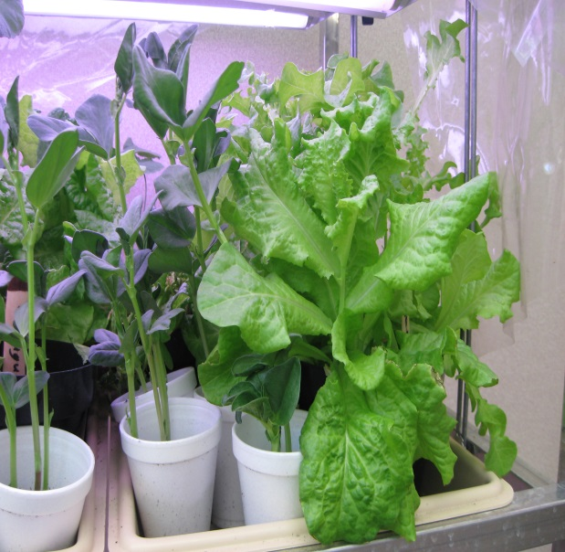
countertop to grow mesclun
(lettuce), radishes, basil, or
another quick growing, edible
plant. Make your system
aesthetically appealing since it
will be highly visible for a long
period of time.

Criteria & Constraints
• Minimize risk of water damage
• Transportable (during breaks, if needed)
• Use available lighting systems
• Compact (12”x12”x12” max)
• Well‐constructed
• Aesthetically pleasing, including labels
• Use materials from trash or recycle bin
• Work in pairs (or individually, as approved)
• Extensive documentation of design &
problem‐solving process (use rubrics provided, document with photos, video, etc)
• Ongoing plant documentation using documentation techniques (Extra Credit)

Hydro-Plant Rubric 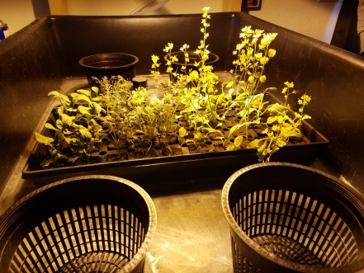
• Design documentation
• Plant documentation (Extra Credit)
• Materials and Cost Analysis
• Function (Does it work?)
• Construction of working model (or 2 dimensional model) & aesthetics
• Creativity & effort
• Extra Credit: Grow a seedling in your working system. Document your progress and results (photos, data collection, etc). [EC up to 50 points.]

