KEY- Unit 1 Lesson 3 and 4 Quizzes (Practice Test)
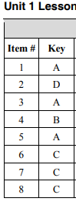
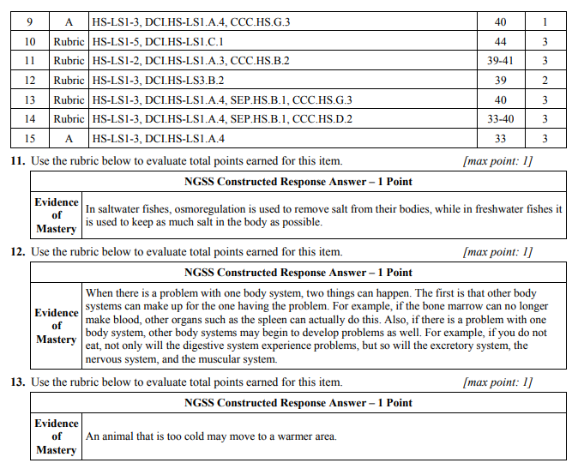
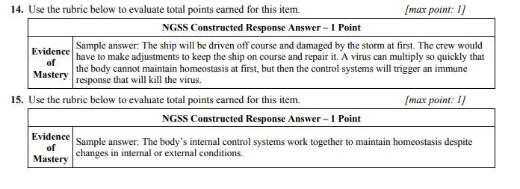
Lesson 4
