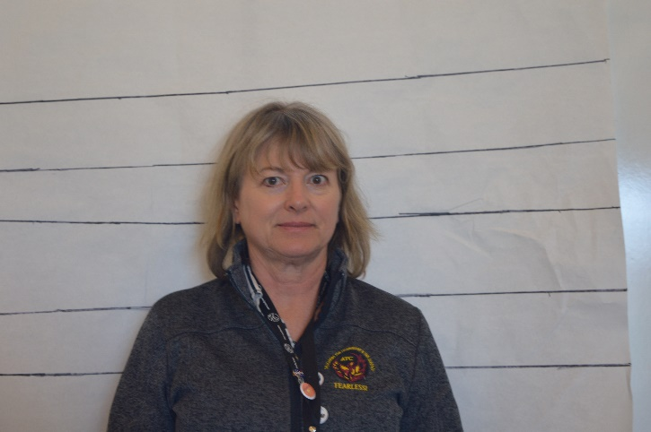 |  | Relationship to the Professor:  - Colleagues at the Math and Science Institute;  - Worked for several years together on a very successful project  - Both received widespread acclaim in their respective fields;  Does Dr Brown feel threatened with the Professor on her turf at ATC?  Alibi: I had a massage 10 AM Saturday. Then I had lunch and did some light shopping before heading to my hair appointment in Albuquerque at 3:00 PM. I may leave early. I stayed the night in Albuquerque and returned to Santa Fe Sunday morning. I did drop by ATC at some point but I don't remember what time it was. I forgot some papers I needed to grade, so I ran in and picked them up.  General Information:  1. Occupation/Hobbies (side jobs, interests, etc): I facilitate teacher training as an extra job. Hiking, biking, home improvement, cooking, foodie, traveling, rafting, dancing, music  2. Shoe Size: 7.5 - 8  3. Medical info- (Allergies, injuries, etc) Gluten intolerant and I have a pinched nerve that causes numbness in my right hand (right handed), but sometimes I use my left hand when my right hand is hurting.  4. Extra curricular things- what do you do in your free time? See #1  5. Marital status: w/ name of spouse/other: Divorced twice and currently living with Howard. We have been together 14 years.  6. Make/model of vehicle you drive I just sold my Subaru Outback and bought a 2019 Honda Civic/White  7. Lipstick? Various shades of pink and rose usually  .

Dr. Lori Brown
Teacher

CONTACT
PHONE:

EMAIL:
Lori.brown@atcschool.org

