WRL reference M01 D01
Module M01 Ecosystems – Coral Reefs
Data set D01 The effect of light on coral morphology in the Caribbean
_________________________________________________________________________________

Data collection methods:
This exercise uses a series of photographs showing colonies of Montastrea cavernosa, a common reef-building coral from the Caribbean. The photos were taken on a reef called Pelican 3 in the Cayos Cochinos Marine Protected Area, a remote chain of islands off the north coast of Honduras in Central America. Each photo (which can be found in the folder 4. Data for tasks) shows a close-up of a different coral colony with a mini-quadrat held against it (each quadrat is 8cm x 8cm, which means it covers 64cm² of the coral). The corals were chosen at random from a range of depths during a 50 minute long SCUBA dive, and the depth of each coral colony was recorded on a diving slate. Photographs were taken using a Canon 500D SLR camera in a Sea & Sea underwater housing and lit with dual Sea & Sea strobes.

Analysis methods:
To analyse the data here, you will need to open each photograph and count the number of coral polyps within the quadrat. You will find that many polyps around the edges are partly inside and partly outside the quadrat. As a rule you should only count those polyps that are over half inside the quadrat (which usually means you can see the small circular mouth in the centre). To give you a better idea of how to do this, there is an example of an analysed image called “Image 2 (Analysed)” in the photographs folder. Compare this photo to the original “Image 2” and you will see how the polyps should be counted (also see below).

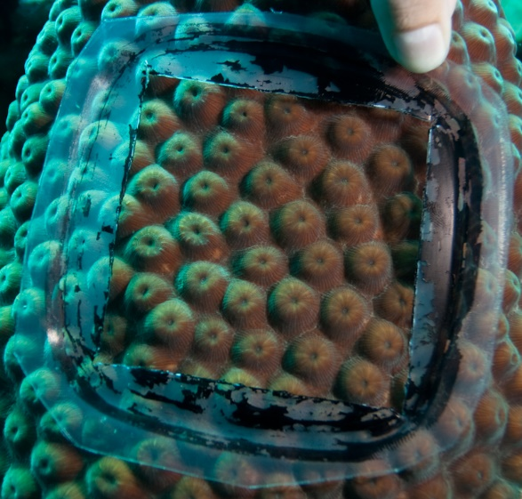 | 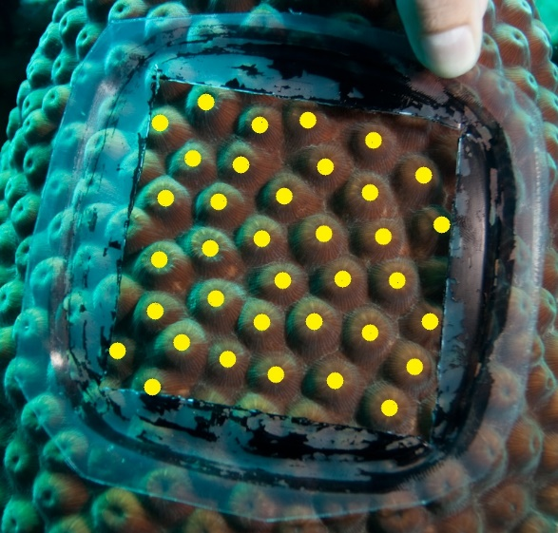
Image 2. Although the majority of polyps are inside the quadrat, you will see that many are only partly inside. | Image 2 (Analysed). This image shows which polyps should be counted. The general rule is that only polyps that are over half inside the quadrat should be included.
NOW OPEN THE FILE “M01 D01 BLANK.xls” (located in the folder 4. Data for tasks)

n.b. the instructions below are for Microsoft's Excel spreadsheet (2007) for the PC and the detailed procedures may will differ for other platforms e.g. Macs.

When you have counted the number of polyps in each photograph, you should add that data to the “Blank” Excel spreadsheet. This spreadsheet already contains the image number and the depth that the photograph was taken. You should enter the number of polyps that you counted in the column titled “No. corallites in quadrat”. You will also notice that next to this is another empty column titled “No. corallites per 100cm²”. It is always important when carrying out research that you convert your data to a standard unit that makes it easier to understand. Recording the number of polyps per 64cm² is a slightly random area to choose, so it is best to multiply it up to being per 100cm² (although you could choose to change it to other rounded areas if you prefer).

To convert your data, the simplest way is to let Excel do the calculations for you by typing in a formula. If you click the mouse in cell D2, type an equals sign (=), which tells excel that you are about to enter a formula that it should calculate for you. Now type the following formula:

(C2/64)*100

If you now click enter, the cell should show the answer to your calculation (which for Image 1 should be 67.1875). By typing C2 into the formula, you are telling excel that you want to divide the number that is in cell C2 by 64, and then multiply the answer by 100. If you now click back on cell D2, you will see there is a small black box in the right hand corner. By double clicking on that box, Excel will copy the formula into the other cells in column D, and will use the corresponding cell in column C each time. Your calculations are now complete.

IF YOU OPEN THE FILE “M01 D01 CALCULATED.xls” YOU CAN CHECK THAT YOUR CALCULATIONS ARE ALL CORRECT

Now you need to find a suitable way of displaying your data, and checking if there is actually a relationship between depth and corallite density. When you are looking for relationships between two variables, the best type of figure (or graph) to use is a scatter plot. The benefit of a scatter plot is that, once you have plotted your data, you can also test the strength of the relationship by using a regression analysis.

To do this, highlight the column titled “Depth”, then hold CTRL and also highlight the column titled “No. of corallites per 100cm²”. If you now click on “Insert” and then “Scatter”, Excel will create a graph of the highlighted data. You will now want to make the figure more presentable by adding titles to both the x-axis and the y-axis (remember to include units on both of these), and a title to the whole graph (beginning with “Figure 1. XXXXXX). It is also advisable to delete the gridlines to make the data clearer.

You will see straight away what seems to be a clear relationship between depth and corallite density, but in science it is important to prove there is a relationship instead of assuming. To do this, you need to run a linear regression analysis, which is very easy to do in Excel. By running a linear regression analysis, you will be able to show clearly how strong a relationship is, and even produce a formula that can be used to predict the polyp density at any given depth.

To do this right click on one of the data points in the graph, and select “Add trendline”. This will open box with a number of options in it. Make sure that “Linear” is selected, and that the boxes for “Display R²” and “Show equation” are both ticked, and then click ok. This will add a trendline (or a line of best fit) to your graph to show the direction the relationship goes. You will see that for this data the line slopes downwards, indicating that as you go deeper on the coral reef, the polyp density (or number of polyps per 100cm²) decreases.

Excel will also have added an R² value next to the line. An R² value tells you how well the trendline actually represents the data, and ranges from zero to 1. The closer R² is to 1, the more reliable the trend in the data is, whereas the closer it is to zero, the weaker the trend is. This data set should give you an R² value of 0.6482, which indicates a fairly strong relationship between depth and corallite density. Above the R² value on the graph will also be a formula (in the form of y = mx + c). You could now use this formula to predict the polyp density at any depth.

IF YOU OPEN THE FILE “M01 D01 COMPLETED.xls” YOU CAN CHECK THAT YOUR GRAPH AND REGRESSION ANALYSIS ARE CORRECT

