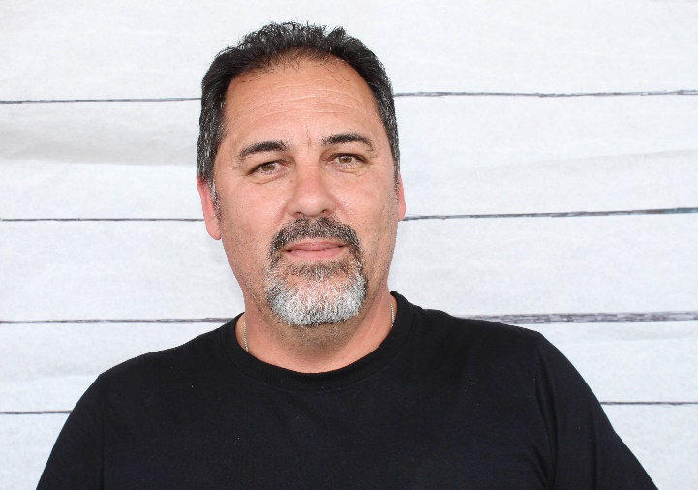 |  | Relationship to the Professor:  - Maintains lab after Professor's experiments;  - Gives Professor access to lab when early morning;  - Have mutual friends and sometimes have dinner together;  - Volatile, Mike can be jealous of Jen's friendship with the Professor  Alibi: I was at home in the morning, working on my truck...and around 2pm I went for a ride on my Harley. I had been riding for a while when I go a phone call from the alarm company that the alarm at ATC was going off...I rode over and shut it off. There were a few cars there and I just figured someone had accidently set it off. I was home about 530.  General Information:  1.Occupation/Hobbies (side jobs, interests, etc)- Maintenance man; Ride Harleys and play basketball  2. Shoe Size: Size 10  3. Medical info- (Allergies, injuries, etc) NA  4. Extracurricular things- (what do you do in your free time?) motorcycle riding, basketball  5. Marital status: w/ name of spouse/other. Married Jennifer Cintas  6. Make/model of vehicle you drive- 2013 Ford f150  7. Lipstick? Uh, no

Mike Cintas
Maintenance

CONTACT
PHONE:
678-555-0103

EMAIL:
mike.cintas@atcschool.org

