AP Biology 2019-20 Reference Material

Big Ideas
AP Biology is based on 4 Big Ideas. Think of them as themes that recur throughout every unit throughout the year.

- Evolution:The process of evolution drives the diversity and unity of life.
- Energetics: Biological systems use energy and molecular building blocks to grow, reproduce, and maintain dynamic homeostasis.
- Information Storage and Transmission: Living systems store, retrieve, transmit and respond to information essential to life processes.
- Systems Interactions: Biological systems interact, and these systems and their interactions exhibit complex properties.

Major Units
The AP Bio curriculum is divided into 8 Major Units. The table below shows approximately what percentage of the exam is based on each topic. Our actual units throughout the year are based on this outline, although some larger topics are broken into two smaller ones.

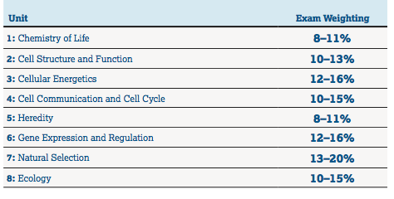
Here are links to the Unit Overviews for the whole year. They contain the detailed information that you’re required to know for each unit, both for this course and for the AP Exam.

Unit 1 Chemistry of Life
Unit 2 Cell Structure and Function
Unit 3 Energy
Unit 4 Photosynthesis and Respiration
Unit 5 Cell Communication and Cell Cycle
Unit 6 Heredity
Unit 7 Gene Expression and Regulation
Unit 8 Natural Selection
Unit 9 Evolutionary Patterns
Unit 10 Behavior and Population Ecology
Unit 11 Community and Ecosystem Ecology

Science Practices
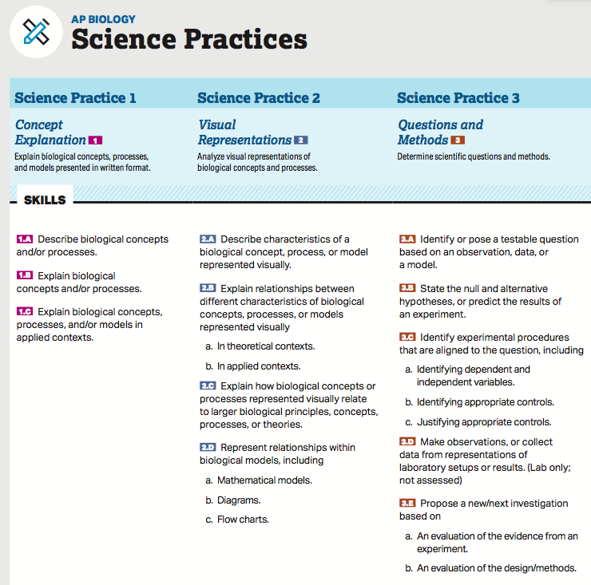

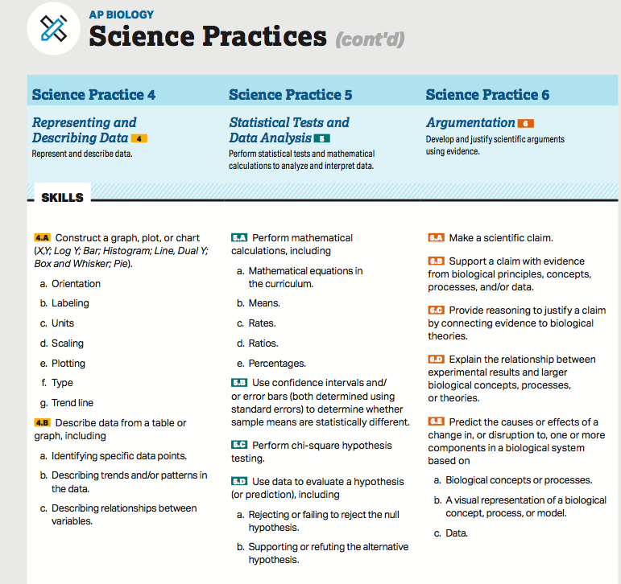

Formulas
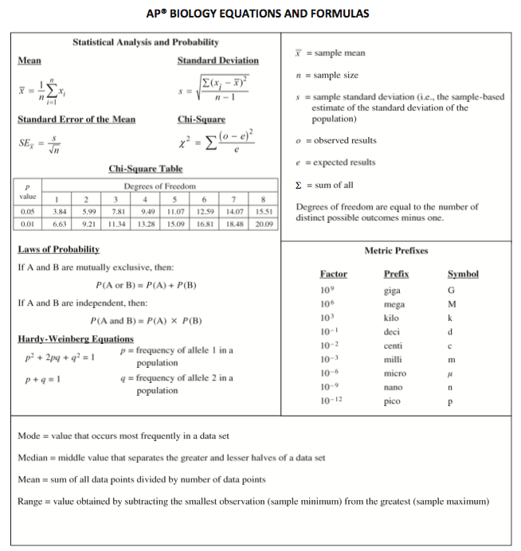

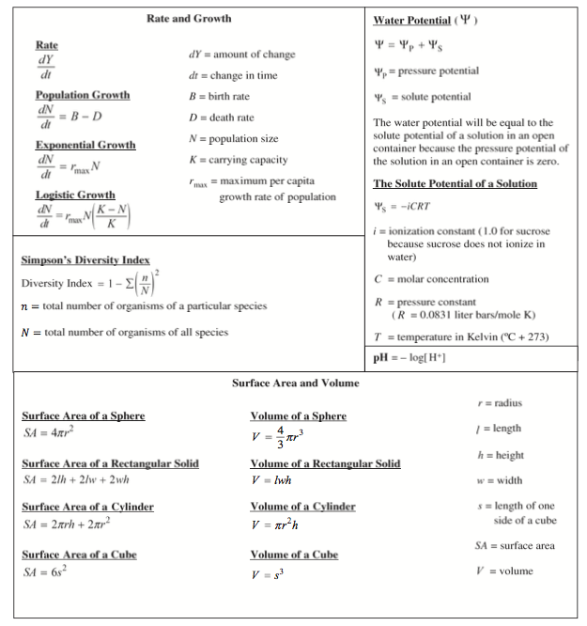

Task Verbs Used In FRQs
