Chapter 3, part 1, Concept 3.1: Carbon and Functional Groups (assign as needed)

Big Picture Questions
This is a big chapter. To make it more digestible, we’re going to break it into two chunks. This first chunk focuses on the chemistry of carbon. This might not be an area in which you’ve had much exposure or context, so, for this one chapter, there’s just one pre-reading question:
- Carbon is the central atom in the molecules that make up living things. What do you know about carbon’s structure? What’s so special about it? Draw an electron orbital model of carbon, and use what you know about covalent bonds to intuit why carbon is so well suited to play its central role in life.
- Read the Chapter Review at the end of the chapter. Because we cover the entire chapter, please read all of the concept reviews, and spend a moment thinking about the review questions.
- Dig in and read the chapter.

Overview
- What are organic compounds?
- Define macromolecule.

Concept 3.1: Carbon atoms can form diverse molecules...
- Describe how the structure of carbon allows it to form such a wide variety of molecules
- Describe and draw examples showing how carbon atoms (and other atoms) can form chains, rings, and branched molecules.
- What are hydrocarbons? Why are they important, both biologically and economically.
- Distinguish between the three types of isomers (structural, cis-trans, and enantiomers)

Chemical groups (AKA Functional groups)
- Learn the following functional groups, and explain how the presence of this group affects the chemistry of the molecule it’s attached to:
  - Hydroxyl,
  - Carbonyl
  - Carboxyl
  - Amino
  - Sulfhydryl
  - Phosphate
  - Methyl
Note: Here’s a table with the seven functional groups you’ll need for making flashcards. You can put the formula in front, or in back. Or, try hangman questions!

 | 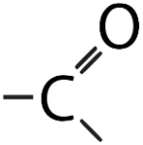 | 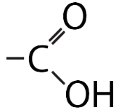 | 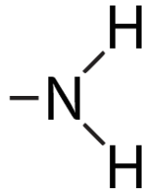
 | 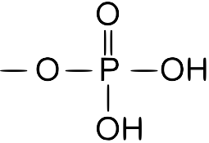 | 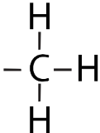 | 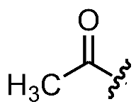  Note: there’s a carbon at the angle vertex

- Read and summarize the section on ATP: we’ll come back to this essential molecule later in the course.

After Reading
Interact
- Do the interactive exercises connected with this chapter on sciencemusicvideos.com

Master the content
- You have 3 options: Cornell Notes, flashcards on your qwizcards webpage (create acct) or qwizcards.com/wizard, or physical flashcards. Always spend time reviewing previous flashcards or Cornell notes.

