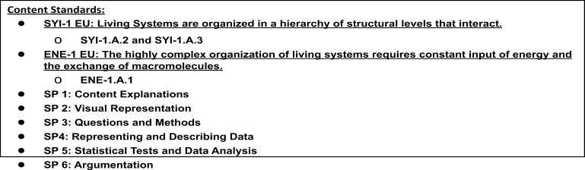

Background Information:
Water is a polar molecule. The oxygen atom in water has a greater electronegativity, or a stronger “pull,” on the electrons that it shares with the two hydrogens it is covalently bonded to. As a result, the molecule ends up having a partially negatively charged end, near the oxygen, and a partially positively charged end near the hydrogens. Much like a magnet, opposite charges will attract and similar ones will repel so that the slightly negatively charged oxygen of one water molecule will be attracted to the slightly positively charged hydrogen of a neighboring water molecule. This weak attraction and “sticking together” of polar molecules is called hydrogen bonding.
Water is an extremely important molecule in biology. Life came from the earliest watery environments, and thus all life depends upon the unique features of water which result from its polar nature and ‘stickiness.’ Some of the unique properties of water that allow life to exist are:
- It is less dense as a solid than as a liquid.
- It sticks to itself –cohesion– cohesion is also related to surface tension.
- It sticks to other polar or charged molecules –adhesion– adhesion results in phenomena such as
capillary action.
- It is a great solvent for other polar or charged molecules. This results in a hydration shell forming around ions.
- It has a very high specific heat –that is, it can absorb a great deal of heat energy while displaying only small increases in temperature.
- It has a neutral pH of 7, which means the concentrations of H⁺ and OH⁻ ions are equal.

Question: How will different additives affect hydrogen bonds between different water molecules?

Materials: Penny, distilled water, various mixtures, pipette, paper towel

Safety: Soap can be an irritant. Take caution to avoid contact between soap and eyes.

Procedure:
- Obtain a DRY penny and place it on a DRY paper towel.
- Using a clean pipette, add distilled water to the penny drop by drop until it overflows. Be sure to count the drops! Record the number of drops for Trial 1 in Data Table 1 below.
- Repeat steps 1-2 for a total of five trials.
- Obtain a DRY penny and place it on a DRY paper towel.
- Repeat for a total of 5 trials.
- Repeat the process with the other solutions.
Data Collection:
Data Table 1: Number of Drops of Distilled Water Contained on the Surface of a Penny
Trial | # Drops Distilled Water | # Drops Distilled Water + Soap | # Drops Distilled Water + sugar | # Drops Oil
1
2
3
4
5
Mean

Data Analysis: Do the appropriate calculations in Data Table 2 below.

Data Table 2: Statistical Analysis of the Number of Drops of Distilled Water Contained on the Surface of a Penny
Calculation | # Drops Distilled Water | # Drops Distilled Water + Soap | # Drops Distilled Water + sugar | # Drops Oil
Mean
Standard Deviation
+/- 1 std dev
+/- 2 std dev
Standard Error of Means
+/- 2 SEM

Create an appropriately labeled bar graph to illustrate the sample means for all solutions within 95% confidence (+/- 2 SEM). Don’t forget a title that includes the independent and dependent variables and axes labels with units. (Graphs are worth up to 4 points on the AP test for plots, labels, and confidence intervals.)

Guided Inquiry Experiment

There are several other solutions on the counter containing salt, vinegar, and baking soda. There are also nickels, dimes, and quarters.

Design your own surface tension experiment following the same outline as before. You only need to do 2 of the new solutions. You will need to write your hypotheses, write your procedure, create data tables, perform the statistical analysis (you can use Google Sheets), and graph the results.
Procedure

Data Collection:
Data Table 1: Number of Drops of Distilled Water Contained on the Surface of a Penny
Trial

1
2
3
4
5
Mean

Data Analysis

Data Table 2: Statistical Analysis of the Number of Drops of Solution
Calculation

Mean
Standard Deviation
+/- 1 std dev
+/- 2 std dev
Standard Error of Means
+/- 2 SEM

Argumentation
CER – Claim, Evidence, Reasoning
- Make a Claim about how additives affect hydrogen bonds between water molecules.

- Using data from this experiment, provide Evidence that supports the claim.

- Using background knowledge and data from this lab, provide Reasoning that uses the evidence to justify the claim.

