Flowchart Set-Up (Replaces “Procedures” in Lab Write-Up)
A QUALITY flowchart has 5 elements:
- Experimental Set-up Diagram - A labeled diagram of your experiment. It includes all materials in their final assembled state.
- Input Arrow (“i”ndependent variable) - Identifies the thing “i” change in the experiment (if appropriate).
- Output Arrow (“d”ependent variable) - Identifies the “data” gathered/measured with units (if appropriate).
- Constants/Control Box - Identifies the things that should remain the same for each member of the experimental group. Identify control group (if appropriate). UPPER LEFT CORNER
- “Key Steps” Summary of procedure (bullet points) - A simplified explanation of how to set up your experiment, and all calculations to be used in your analysis of data. RIGHT SIDE OF DIAGRAM

Example: Britney wants to know how different colors of light affect the growth of plants. She believes that plants can survive the best in white light. She buys 5 plants of the same species. She places one in white light, one in blue light, one in green light, one in red light and one in the closet (control). She measures their initial height on Day 1. All of the ferns are planted in 500 mL potting soil with Miracle-Grow and given 20 mL of water once a day for 2 weeks. After the two weeks, Britney measures their final height in centimeters.

(strong suggestion: start with a rough draft of your flowchart, refine, then add to lab notebook)
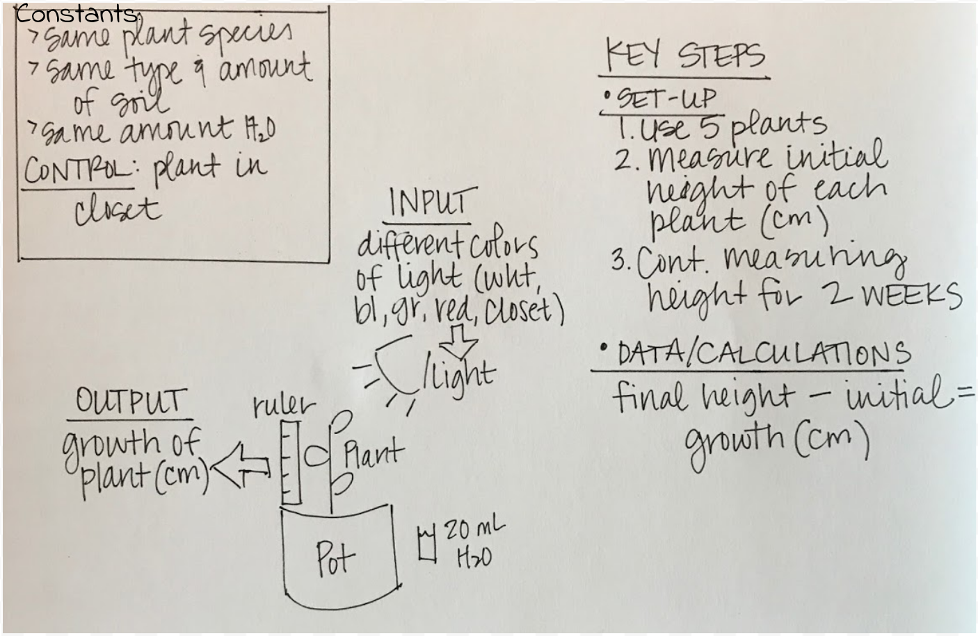
Safety Considerations: careful with hot light bulbs

