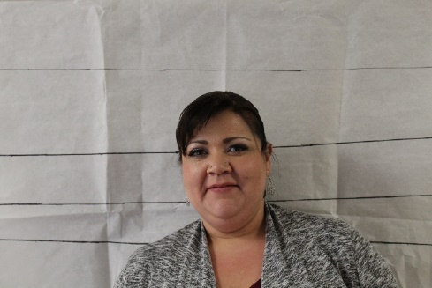 |  | Relationship to the Professor:  - Provides access to lab for the Professor's experiments;  - General point of contact at ATC;  - Have mutual friends  - Sometimes have dinner together; friendly  Alibi: I had a hair appointment about 10am on Saturday and then I had an early lunch. After that I went to my weekly nail appointment and ran some errands. The alarm at the school went off about 4pm and I was heading over to ATC to turn it off. But Mike called and said he would take care of it, so I didn't end up going over. I got home about 630.  General Information:  1.Occupation/Hobbies (side jobs, interests, etc)- Office Manager, motorcycle riding, crocheting  2. Shoe Size: 8  3. Medical info- (Allergies, injuries, etc) NA  4. Extracurricular things- (what do you do in your free time?) motorcycle riding, crocheting  5. Marital status: w/ name of spouse/other. Married Mike Cintas  6. Make/model of vehicle you drive-Toyota Tacoma  7. Lipstick? Yes

Jen Cintas
Office Manager

CONTACT
PHONE:
678-555-0103

EMAIL:
Jennifer.cintas@atcschool.org

