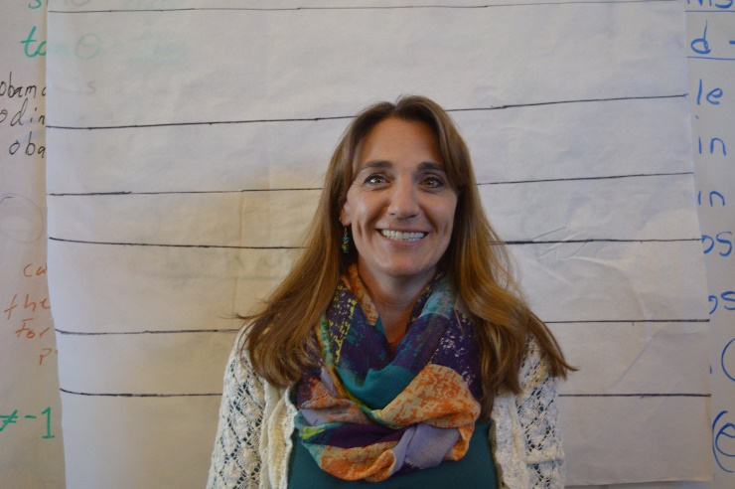 |  | Relationship to the Professor:  - Colleagues at the Math and Science Institute;  - Worked on several projects together during Mrs Victor's engineering days;  - Had a falling out over a civil project and Mrs Victor left her job as a result of it.  Does Mrs Victor resent the Professor enough to kill him?  Alibi: I visited with my mom here in Santa Fe in the morning. After that I was riding horses and eventually ended with going shopping. I did stop by ATC around 4pm on Saturday on my way to the store. I needed to pick up some things for my teacher dossier.  General Information:  1.Occupation/Hobbies (side jobs, interests, etc)-  Teacher; Hobbies: Golf, Horseback Riding, Skiing  2. Shoe Size: Women's 9.5  3. Medical info- (Allergies, injuries, etc) NA  4. Extracurricular things- (what do you do in your free time?) In my free time, I like to spend time with my three kiddos!  5. Marital status: w/ name of spouse/other. Married to Manolo Victor  6. Make/model of vehicle you drive- 6. Dodge Durango  7. Lipstick? Lipstick sometimes, lip balm all the time.  .

Jessica Victor
Teacher

CONTACT
PHONE:

EMAIL:
Jessica.victor@atcschool.org

