Levels of Organization in Biology

1. For each level of organization from molecule to ecosystem, give an example from our analysis of pelicans flying.

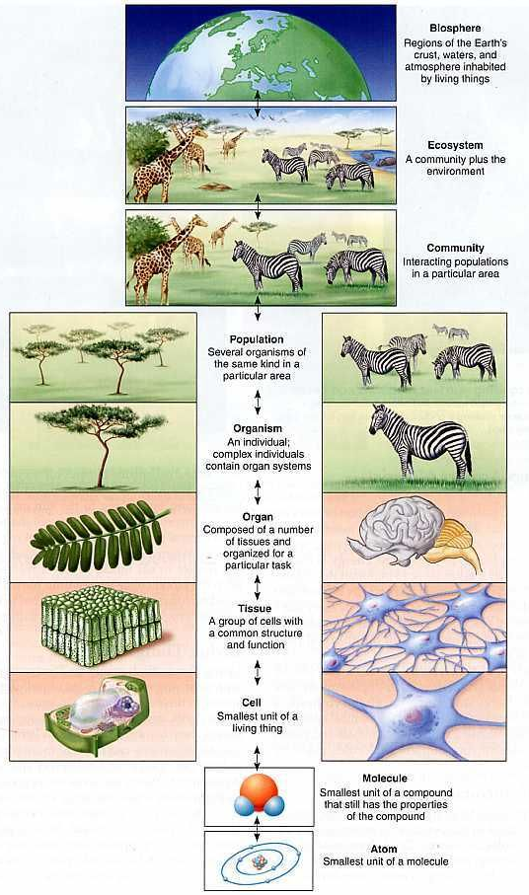

2. This diagram shows the major flight muscles of a bird. Draw in the brain, spinal cord and nerves to the muscles. Explain how the nervous system and muscles work together to produce flight.
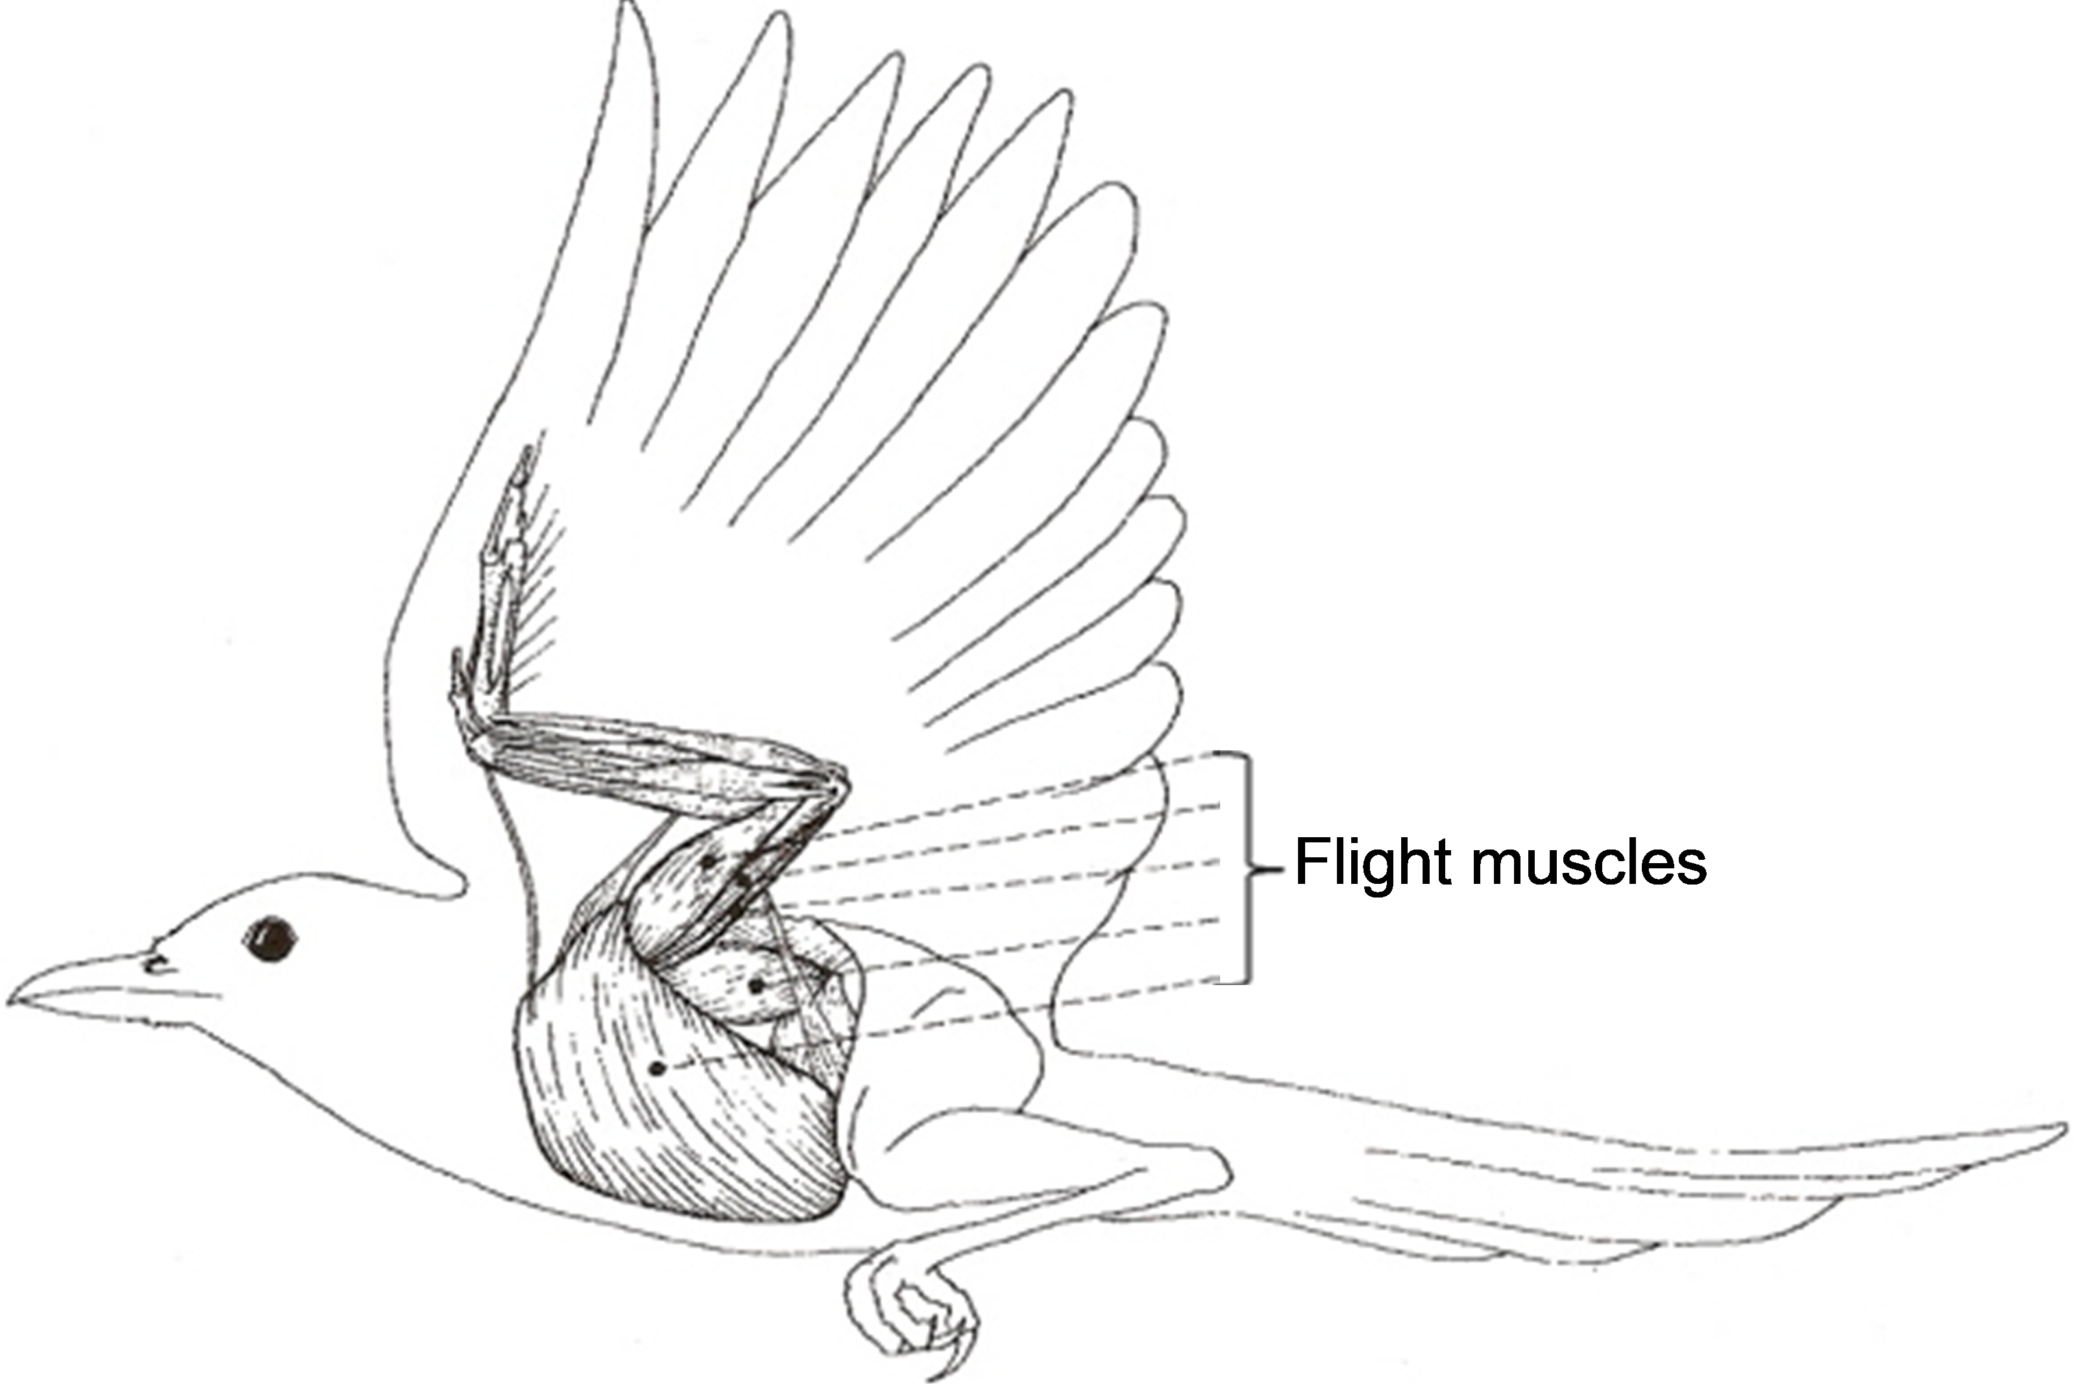
3a. Define reductionism.

3b. Explain how reductionism helps us to understand how birds fly.

This diagram shows the circulatory system of a bird. Each labeled part (other than the heart) shows the location of small blood vessels where molecules like oxygen can enter or leave the blood.

4. Explain how the parts of the circulatory system work together to help the bird fly.

5a. Define an emergent property.

5b. Explain how bird flight is an emergent property that results from the interaction of multiple organ systems.

6. Match each item in the list on the left with the best match from the list on the right.

_____ Biosphere A. All living things on earth and the parts of the earth they inhabit

_____ Cell B. A group of atoms bonded together

_____ Community C. A group of one kind of organism living in an area

_____ Ecosystem D. A group of similar cells working together

_____ Molecule E. Populations of different types of organisms living together

_____ Organ F. A living individual which contains one or more cells

_____ Organ System G. A structure with several tissues that work together to
accomplish a function

_____ Organelle H. All the living and nonliving things in the same environment

_____ Organism I. Parts of a cell such as the nucleus

_____ Population J. A group of organs working together

_____ Tissue K. Smallest level at which life exists

7. Put the levels of organization listed above in order from smallest to largest, and give an example of each level of organization for a population of squirrels living in a forest.

Level of Organization | Example for a Population of Squirrels Living in a Forest
Smallest:
Largest:

By Dr. Ingrid Waldron, Department of Biology, University of Pennsylvania, and Bradley String, Ridley High School, © 2019. This Student Handout, a PowerPoint presentation, and Teacher Notes with suggested questions and points to include in the PowerPoint presentation are available at https://serendipstudio.org/exchange/bioactivities/LevelsOrganization.

