Atoms bond together to make molecules. Many molecules can also bond together to form bigger molecules. Molecules that make up living organisms are often large and complex. For example, many biologically important carbon-based molecules are polymers, which are composed of many simple subunits called monomers. Starch is composed of many simple sugar units bonded together. Proteins are made of many amino acids bonded together. Nucleic acids, such as DNA, are made of long strands of subunits called nucleotides.
MATERIALS
• ball, Playdoh Color 1 (9)
• ball, Playdoh Color 2 (3)
• protractor
• toothpicks
Scientists often use models to help study and understand atoms and molecules. Biochemists use computers to make molecular models in which all the atoms and atomic bonds of a molecule are included. In this lab, you will use ordinary materials to model atoms, small molecules, and polymers.
predict
How do atoms, molecules, and polymers compare?

Procedure

Part 1: Modeling atoms and molecules

1. Make a model of a glucose molecule's ring structure. Glucose is composed of a ring of 5 carbon atoms and an oxygen atom. Obtain Playdoh Color 1. These will represent carbon atoms. Use toothpicks to “bond” the atoms together at ~120° angles. For simplicity, additional oxygen and hydrogen atoms bonded to the ring will not be included in the model.
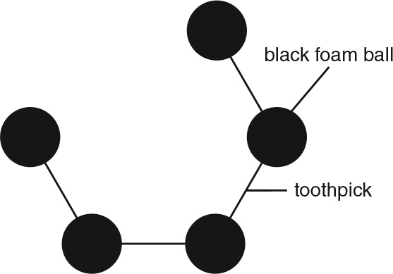
2. Use toothpicks to attach a Playdoh Color 2 ball (oxygen) to complete the ring structure of glucose. Glucose is a simple sugar, or monosaccharide.
3. Build a model of another simple sugar, fructose. Fructose contains a ring of 4 carbon atoms and an oxygen atom bonded together. As with the model of glucose, additional hydrogen and oxygen atoms bonded to the ring will not be included in your model. Connect Playdoh Color 1 balls together with toothpicks at ~108° angles. Complete the ring with toothpicks and a Playdoh Color 2 ball.
Attach the Playdoh Color 1 balls (carbon atoms) together at 108° angles.
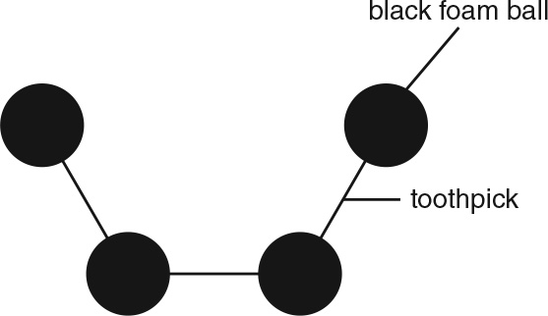
4. Make a model of sucrose (a disaccharide) by bonding the glucose to the fructose.
Connect one of the carbon atoms that is next to the oxygen atom in your glucose model to another oxygen atom, as shown.
Connect a Playdoh Color 2 (oxygen) ball to the glucose model.
5. Insert a toothpick into the new oxygen atom. Use it to connect the oxygen to a carbon that is next to the oxygen in the fructose model.
Part 2: Modeling polymers
6. Connect several glucose molecules together to model the polysaccharide called starch.
7. Make a model of an amino acid chain to represent part of a protein molecule. Use Playdoh balls to represent the amino acids. Each ball represents an individual amino acid.
8. Make an amino acid chain similar to the way in which you constructed your model of starch.
Analyze
1. How are glucose and fructose similar? How are they different?

2. How are starch and sucrose similar? How are they different?

3. What are some similarities between your protein and polysaccharide (starch) models?

4. Describe the strengths and weaknesses of using these models to represent monomers and polymers.

