Name_________________________________________________________ Unit 4: Cell communication

- Describe the ways Cells can communicate with one another
- Identify the type of communication in each diagram as direct contact, short distance, or long distance AND JUSTIFY your answer for each

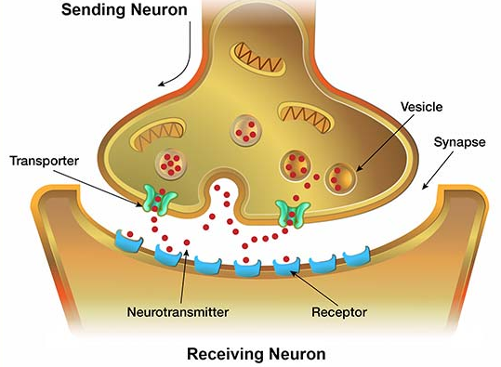

- Explain Why cell communication is important

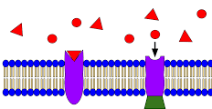
- Explain hoe cells communication with one another
- Identify the ligand in the following diagram

- Explain the purpose of the ligand

- Describe how a ligand can activate a cell

- Describe how different types of ligands interact with a cell for communication
- Describe the structural properties of a steroid hormone

- IDENTIFY the location of the receptor that a steroid hormone will bind with and EXPLAIN why it must bind to the receptor in that location

- Describe the structural properties of a protein ligand

- IDENTIFY the location of the receptor that a protein hormone will bind with and EXPLAIN why it must bind to the receptor in that location

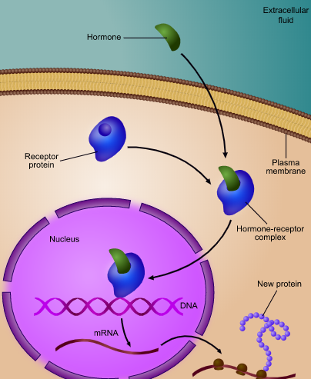

- IDENTIFY the type of ligand that is in the diagram and EXPLAIN why you chose that type of ligand

Name_______________________________________________________ Unit 4: Ligands and Signal Transduction Review

- Ligands can allow the movement of Ions
- Describe how ligands allow for the movement of ions through a ligand gated ion channel

- Explain the importance of ligands on gated ion channels

- Ligands can activate the cell which lead to a signal transduction. Signal transduction pathways link signal reception with cellular responses.
- state the difference between a target cell and non- target cell and explain why you would not want every cell in the body to contain every type of receptor

- Define signal transduction pathway and explain the importance

- Identify and explain the three stages in the signal transduction pathway

Stages 1. 2. 3.
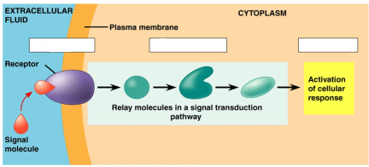

Explain stages:

3. Cells communicate by generating, transmitting, receiving, and responding to chemical signals. Describe the role of components of a signal transduction pathway in producing a cellular response. A series of steps are needed to complete the signal transduction pathway and elicit a response. Explain what is occurring at each step by answering each question

Step 1: Ligand binding to the receptor protein
- Circle and Identify the Ligand in the signal transduction pathway diagram below

- DESCRIBE what happens to the receptor protein when the ligand binds and EXPLAIN its importance

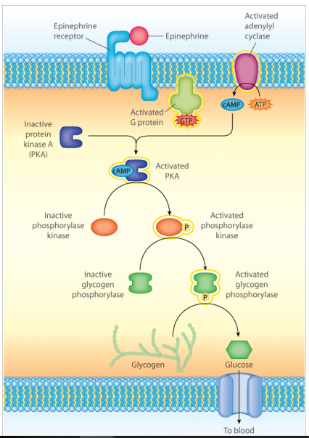

Step 2: Activation of the enzyme adenylyl Cyclase

- Describe the process that activates adenylyl cyclase

- Explain what adenylyl cyclase is responsible for once the enzyme is activated

Step 3: Phosphorylation Cascade
- Circle and label the secondary messenger in the diagram on the previous page and DESCRIBE the overall role of cAMP on the signal transduction pathway

- Explain how cAMP activates a phosphorylation cascade

- Describe what happens during a phosphorylation cascade

- Explain the importance of a phosphorylation cascade

Step 4: Response
- Identify the types of responses that can occur as a result of signal transduction

- Identify the type of response in the diagrams below
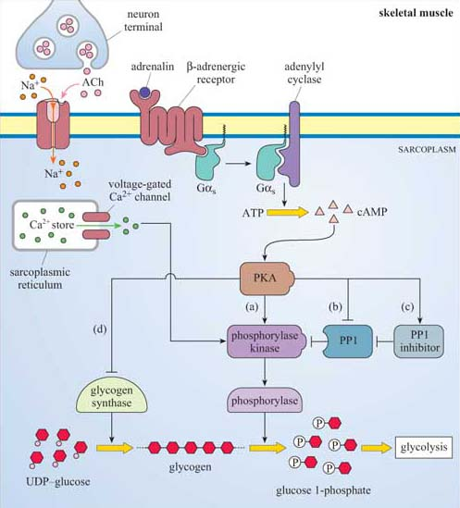

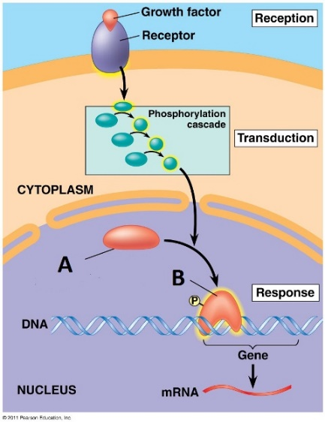

- The signal is often amplified in the cell.
- DESCRIBE what amplification is AND EXPLAIN its importance

- Circle the amplification area
In the diagram to the right

- Chemicals that interfere with any component of the signaling pathway may activate or inhibit the pathway.
- Explain how chemicals can interfere with the signaling pathway

- PREDICT the type of medication (what physical properties would be present) that could inhibit cyclic AMP and turn off a signaling pathway AND JUSTIFY your prediction

- Changes in signal transduction pathways can alter cellular response
- Describe a mutation that could occur to a receptor protein

- Explain what would occur if there was a mutation in the receptor protein

Name_______________________________________________________________ Unit 4: Feedback and Cell Cycle

- Timing and coordination of biological mechanisms involved in growth, reproduction, and homeostasis depend on organisms responding to environmental cues.
- Each physiological condition in the body has a set point. Explain what a set point is and give examples conditions in the body that have a set point

- Identify the types of feedback mechanisms that occur in organisms and Explain why organisms use feedback mechanisms

- Negative feedback works to maintain homeostasis in the organism/cell
- Describe what is occurring in the organism/cell to require a negative feedback mechanism

- Explain how the negative feedback process works to maintain homeostasis in the organism when there is a change to the set point

- For the following negative feedback example below: Identify ONE change that is occurring to the set point and EXPLAIN how negative feedback works to return the system back to its target set point

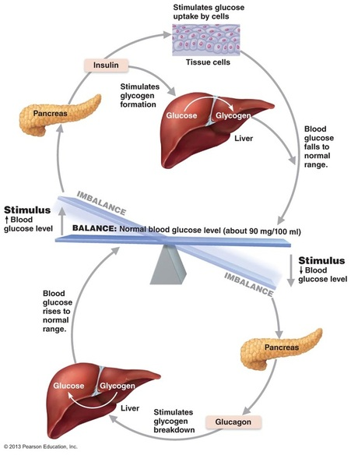

- For the negative feedback example answer the following:
- Describe a mutation that could occur

- Predict the impact the mutation would have on the negative feedback loop

- Justify your prediction

- Feedback inhibition can regulate enzyme catalyzed pathways
- Describe the feedback that is occurring in the diagram below and EXPLAIN its importance

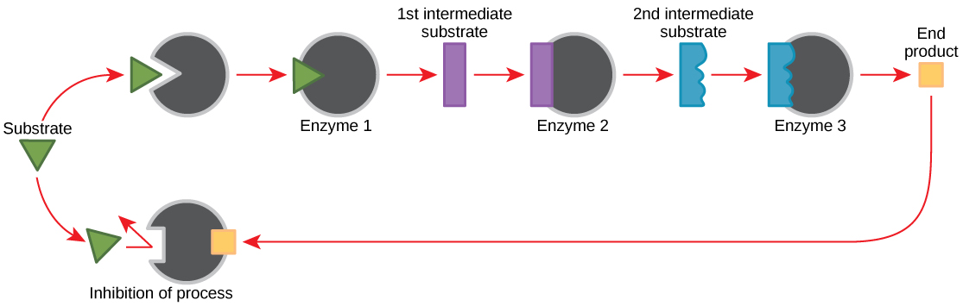

- Identify the structure that is acting as the allosteric regulator in the above feedback

- Explain how positive feedback affects homeostasis.
- Explain what a positive feedback mechanisms do to the responses and process in organisms

- Describe a positive feedback response as a result of a change in the set point.

- Explain the positive feedback that is occurring in the diagram below and state the end result of this positive feedback

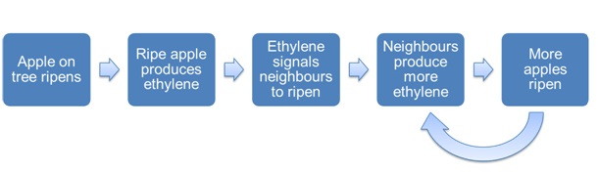

- In eukaryotes, cells divide and transmit genetic information via two highly regulated processes.
- Identify the phases of the cell cycle and Give a brief description of each phase

- Describe what is occurring during the G₁, S and G₂ phases of interphase
- G1

- S

- G2

- Draw a bar graph to show the amount of DNA that would be found in the different stages of the cell cycle if the initial amount of DNA was 4

Amount of DNA per phase Number of Chromosomes per phase
8
7
6
5
4
3
2
1
0
Initial cell
Interphase
Prophase
Metaphase
Anaphase
Telophase
Daughter cells
8
7
6
5
4
3
2
1
0
Initial cell
Interphase
Prophase
Metaphase
Anaphase
Telophase
Daughter cells

- Draw a bar graph to show the number of chromosomes that would be found in the different stages of the cell cycle if the initial number of chromosomes was 4

- Identify the stage a cell enters when it is no longer dividing

- Explain how mitosis results in the transmission of chromosomes from one generation to the next
- Identify the various roles of Mitosis in the body

- Identify the following structures in the diagram below: sister chromatid, centromere, spindle fibers, kinetochore, chromosome

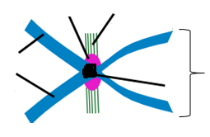

- Describe what is occurring in each of the stages of mitosis
- Prophase

- Metaphase

- Anaphase

- Telophase

- Explain the importance of cytokinesis

- For each picture below, Identify the stage the cell is in( they are not in order): interphase, prophase, metaphase, anaphase, telophase/cytokinesis

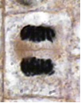
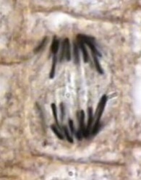
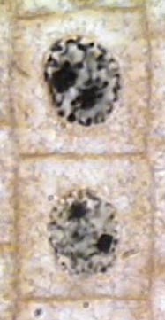
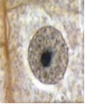

________________ _______________ ________________ __________________ _________________

- For a cell that has undergone mitosis, Describe how newly formed daughter cells compare to the original cell

Name_____________________________________________________________________ Unit 4: cell Regulation

- Describe the role of checkpoints in regulating the cell cycle. A number of internal controls or checkpoints regulate progression through the cycle.
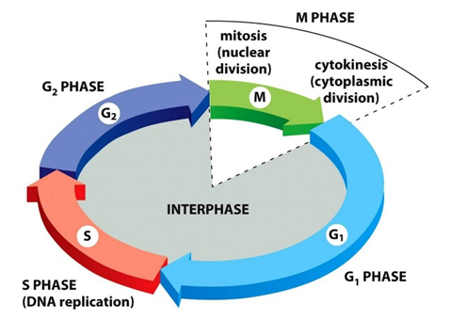
- Label the 3 check points that exist in the cell cycle and EXPLAIN the overall importance of checkpoints in the cell cycle

- Describe the Role of cyclin in cell regulation

- Describe the role CdK ( cyclin dependent kinase) in the cell cycle

- Identify the components of MPF AND DESCRIBE the role of MPF (maturation promoting factor)

- Explain the importance of each checkpoint in the cell cycle
- G1-

- G2 –

- M –
- Interactions between cyclins and cyclin-dependent kinases control the cell cycle.
- Describe what happens to the concentration of Cyclin during the cell cycle and Explain why the change in concentration happens

- Describe the impact the change in Cyclin has on the concentration of MPF

- Describe what happens to the concentration of MPF as the cell progresses through the cell cycle AND EXPLAIN why the concentration of MPF is changes

- Explain how the concentration of MPF is used at each checkpoint to determine if the cell will continue past the check point or not advance

- Graph the concentration of cyclin, and MPF during the cell cycle (interphase and mitosis) and explain what is happening to the concentrations of each

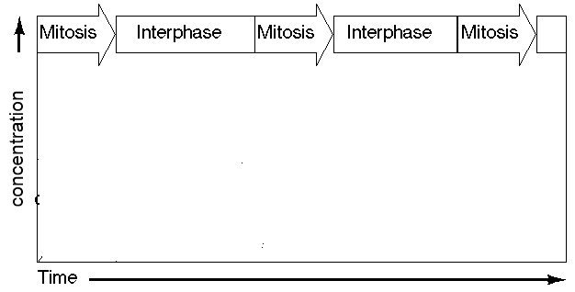

- Explain why the concentration decreases as the cell progresses through mitosis

- Explain what happens to the cell if the cell does into pas the G1 checkpoint

- Disruptions to the cell cycle may result in cancer and/or programmed cell death (apoptosis).
- Describe the role of the p53 protein on the cell cycle

- Explain the importance of the p53 protein

- Describe the outcome to the cell when apoptosis occurs AND EXPLAIN why this process is necessary

- Predict what would happen to the cell cycle if there was a mutation in the p53 gene AND JUSTIFY

- Describe what happens to the length of the cell cycle in a cancerous cell AND EXPLAIN why this change happens.

- Predict what would happen to the cell going through the cell cycle if a medication inhibits the formation of cyclin AND JUSTIFY your prediction

