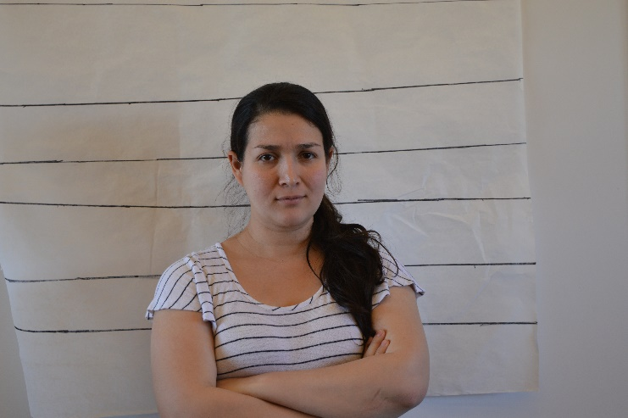 |  | Relationship to the Professor:  - Mentor/mentee;  - The Professor mentors Yima as a new teacher;  - The relationship is friendly  - Yima admires the Professor's work.  Alibi: I went to school for the AP extra class like from 9-11.30 then went back home to stay with my baby until 2. Later, I went to the store like till 4 and then had dinner with my family downtown until 7. We got home about 7 and watched movies until we fell asleep.  General Information:  1. Occupation/Hobbies (side jobs, interests, etc)  Civil Engineer, Climbing, Cooking, Dancing.  2. Shoe Size:  6 1/2  3. Medical info- (Allergies, injuries, etc)  Allergic to avocado  4. Extra curricular things- what do you do in your free time?  Take care of my baby  Tutoring math  Watch Netflix marathons  5. Marital status: w/ name of spouse/other  Married with Mike Moore  6. Make/model of vehicle you drive  Blue Subaru Forester 2011  7. Lipstick? (not you, Mike)  Red  .  .

Yima Cevallos
Teacher

CONTACT
PHONE:

EMAIL:
Yimabel.cevallos@atcschool.org

